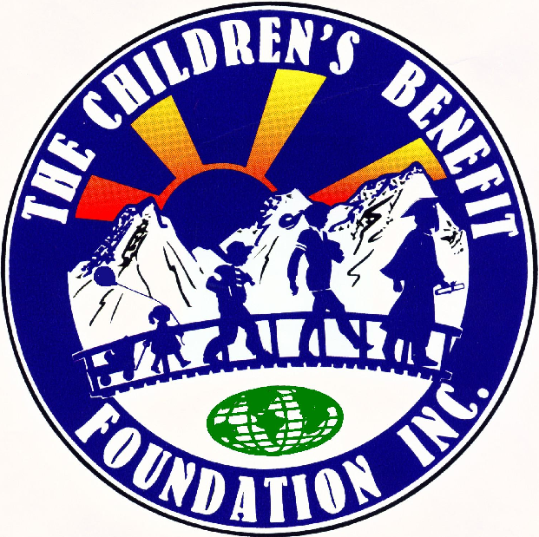
Free Integrative Health Fair
A Community Health Event – Saturday, February 11th, 2023

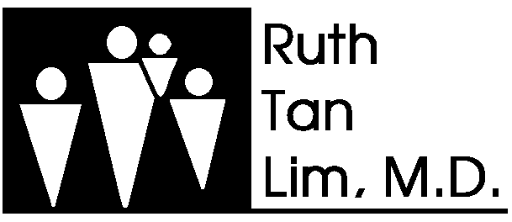
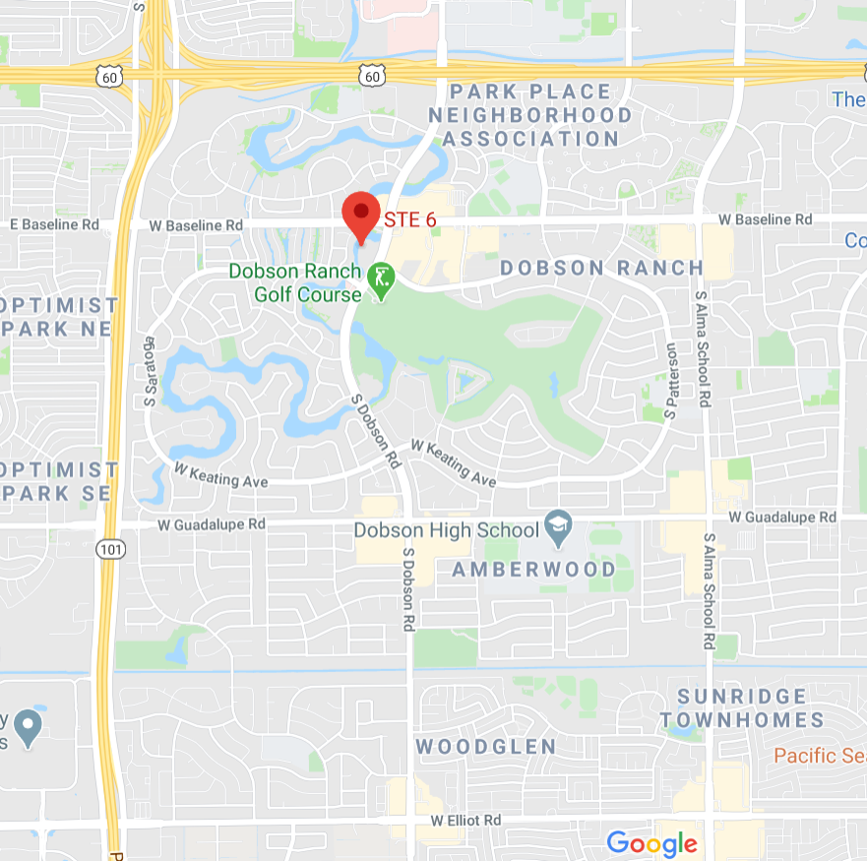
MEDICAL SPECIALITIES

- INTERNAL MEDICINE
- NATUROPATH
- PEDIATRICS
- ACUPUNCTURE
- OSTEOPATHIC MANIPULATION
- VISION EXAM
- FLU SHOTS
- MAMMOGRAM
- BLOOD PRESSURE CHECK
- BLOOD SUGAR CHECK
ESPECIALIDADES MEDICAS

- MEDICINA INTERNA
- NATUROPATA
- PEDIATRIA
- ACUPUNTURA
- MANIPULATION OSTEOPATICA
- EXAMeN DE LOS OJOS
- VACUNAS CONTRA LA GRIPE
- MAMOGRAFIA
- EXAMEN DE LA PRESION SANGUINEA
- EXAMEN DE GLUCOSA EN LA SANGRE

We provide complimentary consultations and services for the different medical disciplines. Please come early. Registration starts at 8 AM.

Brindamos consultas y servicios complementarios para las diferentes disciplinas médicas. Por favor ven temprano. El registro comienza a las 8 AM.
Address/Direccion:
Dobson Integrative Medical Center and Dobson Pediatrics
2058 South Dobson Road, Suite 6
Mesa, AZ 85202

Phone: 480.820.4507

